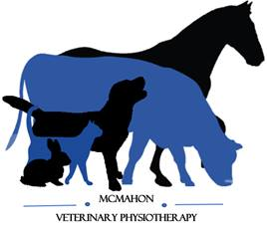
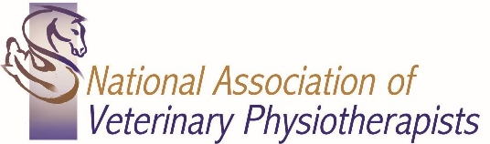

McMahon Veterinary Physiotherapy

Danielle McMahon
BSc (Hons), PgD (Vet Phys), MNAVP, MAHPR
Veterinary Physiotherapist
Veterinary Authorisation and Client Registration Form
(Please complete Client and Animal details and then pass this form to your Veterinary Surgeon, kindly requesting the Vets section is completed and either returned to the owner or myself)

Clients Details
Name:
Address:
Postcode:
Home Telephone: Mobile:
Date:
Animals Details
Name:
Species (Canine/Feline/Equine/Other):
Breed:
Sex: M /F
Neutered: Y/ N
Date of Birth:
Insurance Company: Policy Number:
Date of most recent Vaccination:
Veterinary Practice
Veterinary Surgeon:
Veterinary Practice Address:
Telephone and Email:
Summary of Relevant Medical History and Background:

Medication:
Veterinary Surgeon Declaration: In my opinion, the above-named animal is in a suitable state of health to undergo Veterinary Physiotherapy
Name Printed: Signed: Date:

Danielle McMahon - Veterinary Physiotherapist
07545296642
mcmahonvetphysio@gmail.com

